HttpRequest

Every view function is having one required parameters called request.

This request is of type HttpRequest (class). Server creates HttpRequest object and send to view function.

HttpRequest object contains,
- Information about client (browser/thin client)
- Information send by client

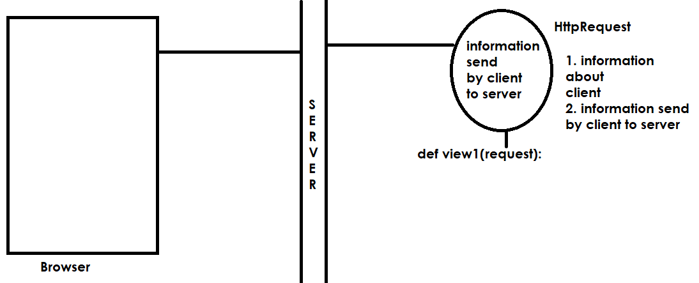

Query String

in request method get the data is send to view by concatenating with URL, the data which is concatenated with URL is called query string.

Query string contains pair values
- Key 🡪 parameter name
- Value 🡪 value of that parameter

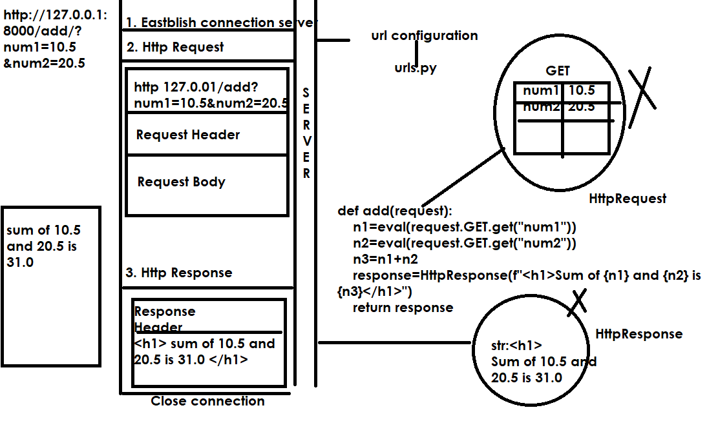

Views.py
from django.shortcuts import render
from django.http import HttpResponse
# Create your views here.

def add(request):
n1=eval(request.GET.get("num1"))
n2=eval(request.GET.get("num2"))
n3=n1+n2
response=HttpResponse(f"<h1>Sum of {n1} and {n2} is {n3}</h1>")
return response

def addtemp(request):
response=render(request,"addtemp.html")
return response

addtemp.html
<!DOCTYPE html>
<html lang="en">
<head>
<meta charset="UTF-8">
<meta name="viewport" content="width=device-width, initial-scale=1.0">
<title>Document</title>
</head>
<body>
<form action="/add" method="get">
<table border="2">
<tr>
<td>Number</td>
<td><input type=text name="num1"></td>
</tr>
<tr>
<td>Number</td>
<td><input type=text name="num2"></td>
</tr>
<tr>
<td><input type="submit"></td>
<td><input type="reset"</td>
</tr>

</table>

</form>
</body>
</html>

Urls.py
from django.contrib import admin
from django.urls import path
from app1.views import add,addtemp

urlpatterns = [
path('admin/', admin.site.urls),
path('add/',add),
path('',addtemp)
]

Settings.py
INSTALLED_APPS = [
'django.contrib.admin',
'django.contrib.auth',
'django.contrib.contenttypes',
'django.contrib.sessions',
'django.contrib.messages',
'django.contrib.staticfiles',
'app1'
]

TEMPLATES = [
{
'BACKEND': 'django.template.backends.django.DjangoTemplates',
'DIRS': [BASE_DIR/"templates"],
'APP_DIRS': True,
'OPTIONS': {

POST method

Views.py

from django.shortcuts import render
from django.http import HttpResponse
# Create your views here.

def add(request):
n1=eval(request.POST.get("num1"))
n2=eval(request.POST.get("num2"))
n3=n1+n2
response=HttpResponse(f"<h1>Sum of {n1} and {n2} is {n3}</h1>")
return response

def addtemp(request):
response=render(request,"addtemp.html")
return response

addtemp.html
<!DOCTYPE html>
<html lang="en">
<head>
<meta charset="UTF-8">
<meta name="viewport" content="width=device-width, initial-scale=1.0">
<title>Document</title>
</head>
<body>
<form action="/add/" method="post">
{%csrf_token%}
<table border="2">
<tr>
<td>Number</td>
<td><input type=text name="num1"></td>
</tr>
<tr>
<td>Number</td>
<td><input type=text name="num2"></td>
</tr>
<tr>
<td><input type="submit"></td>
<td><input type="reset"</td>
</tr>

</table>

</form>
</body>
</html>

Urls.py
from django.contrib import admin
from django.urls import path
from app1.views import add,addtemp

urlpatterns = [
path('admin/', admin.site.urls),
path('add/',add),
path('',addtemp)
]

Settings.py
INSTALLED_APPS = [
'django.contrib.admin',
'django.contrib.auth',
'django.contrib.contenttypes',
'django.contrib.sessions',
'django.contrib.messages',
'django.contrib.staticfiles',
'app1'
]
TEMPLATES = [
{
'BACKEND': 'django.template.backends.django.DjangoTemplates',
'DIRS': [BASE_DIR/"templates"],
'APP_DIRS': True,

def sub(request,num1,num2):
num3=num1-num2
response=HttpResponse(f'Diff of {num1} and {num2} is {num3}')
return response

urls.py
path('sub/<int:num1>/<int:num2>/',sub),

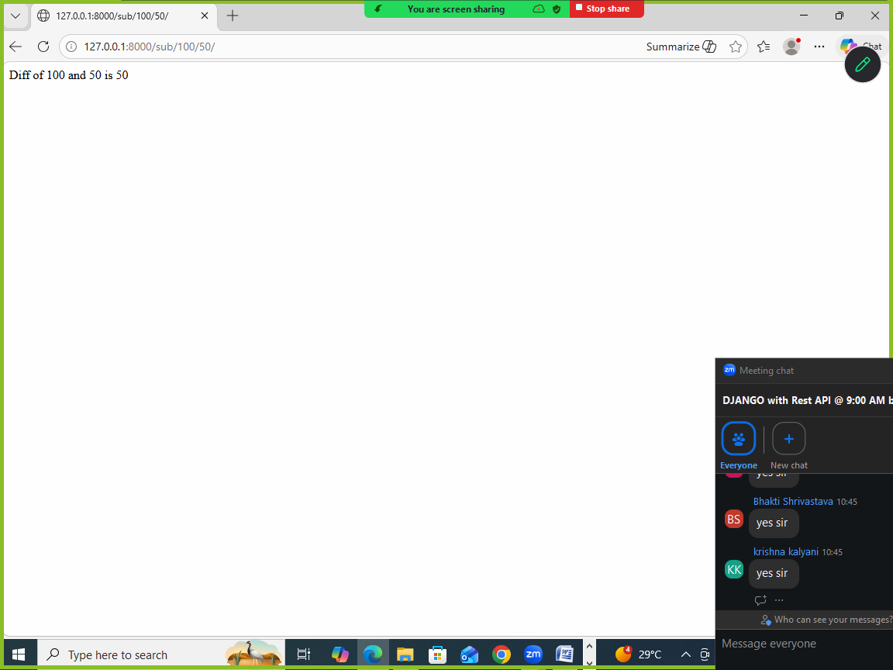

Captured parameters

